SIMATS ENGINEERING
Saveetha Institute of Medical and Technical Sciences
Department of Computer Science and Engineering
ASSESSMENT TOOL 3 — VISUALIZATION DESIGN ACTIVITY (SOLUTIONS)
Course Code | DSA0502 | Course Title | Query Processing for Data Science
CO Assessed | CO5 | Assessment Tool | Tool 3 – Visualization Design Activity
Weightage | 35% | Faculty In-charge | Dr. B. Shyamala Gowri
CO5 Statement:
Create meaningful visualizations using Pandas and Matplotlib, including charts, distributions, relationships, and interactive visual representations for effective communication.
This document presents complete, tested Python solutions for all 12 activities in the Visualization Design Assessment Tool. Each activity includes the task restated, the Python code used, the generated output/plot, and the required analysis or interpretation.

Activity 1 — Basic Plot Creation
Task: Create a line plot using a small dataset of monthly sales. Add a title, x-axis label, y-axis label, legend, and grid.

Python Code
import matplotlib.pyplot as plt

months = ['Jan', 'Feb', 'Mar', 'Apr', 'May', 'Jun']
sales = [220, 260, 240, 310, 290, 350]

plt.figure(figsize=(7, 4.5))
plt.plot(months, sales, marker='o', color='#2E86AB',
linewidth=2, label='Monthly Sales')
plt.title('Monthly Sales Trend')
plt.xlabel('Month')
plt.ylabel('Sales (in units)')
plt.legend()
plt.grid(True, linestyle='--', alpha=0.6)
plt.show()

Output
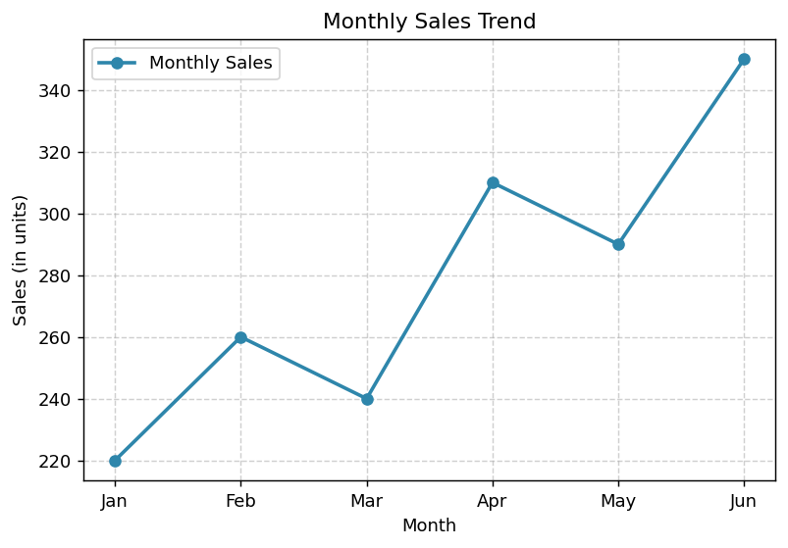
Observation: Sales generally trend upward from January to June, with a small dip in March and May, indicating an overall positive seasonal growth pattern.

Activity 2 — Plot Component Challenge
Task: Given an incomplete Matplotlib program, identify and add the missing title, labels, legend, markers, and grid.

Incomplete Program (as given)
import matplotlib.pyplot as plt

months = ['Jan', 'Feb', 'Mar', 'Apr', 'May', 'Jun']
sales = [220, 260, 240, 310, 290, 350]

plt.plot(months, sales)
plt.show()

# Missing: title, xlabel, ylabel, legend, marker style, grid

Corrected Program
import matplotlib.pyplot as plt

months = ['Jan', 'Feb', 'Mar', 'Apr', 'May', 'Jun']
sales = [220, 260, 240, 310, 290, 350]

plt.figure(figsize=(7, 4.5))
plt.plot(months, sales, marker='s', color='#A23B72',
linewidth=2, label='Sales') # added marker + label
plt.title('Monthly Sales - Corrected Plot') # added title
plt.xlabel('Month') # added x-axis label
plt.ylabel('Sales (in units)') # added y-axis label
plt.legend() # added legend
plt.grid(True, linestyle='--', alpha=0.6) # added grid
plt.show()

Output
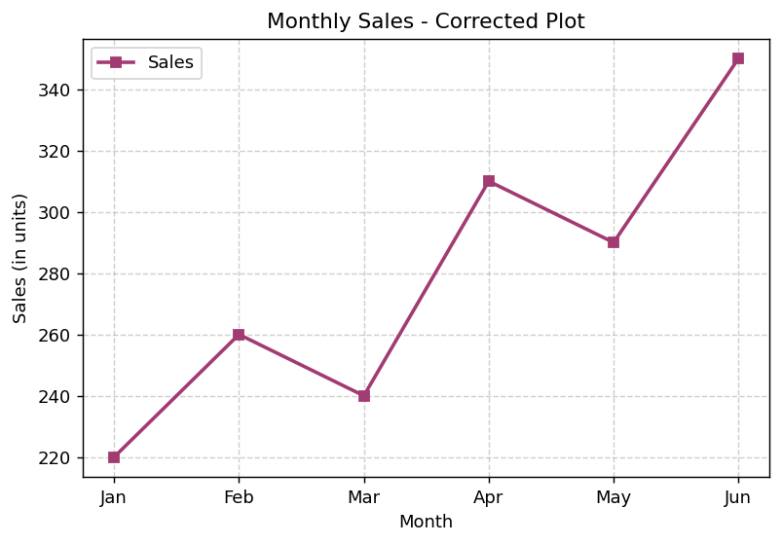
Corrections made: (1) added a descriptive title, (2) added x-axis and y-axis labels, (3) added a legend by supplying a 'label' argument, (4) added square markers to highlight data points, (5) enabled a dashed grid for readability.

Activity 3 — Compare Visualization Types
Task: Use the same dataset to create a line plot, bar plot, and scatter plot. Discuss which visualization communicates the data most effectively.

Python Code
import matplotlib.pyplot as plt

fig, axes = plt.subplots(1, 3, figsize=(14, 4.5))

axes[0].plot(months, sales, marker='o', color='#2E86AB')
axes[0].set_title('Line Plot')

axes[1].bar(months, sales, color='#F18F01')
axes[1].set_title('Bar Plot')

axes[2].scatter(months, sales, color='#C73E1D', s=80)
axes[2].set_title('Scatter Plot')

for ax in axes:
ax.set_xlabel('Month'); ax.set_ylabel('Sales')
ax.grid(True, linestyle='--', alpha=0.6)
plt.tight_layout(); plt.show()

Output
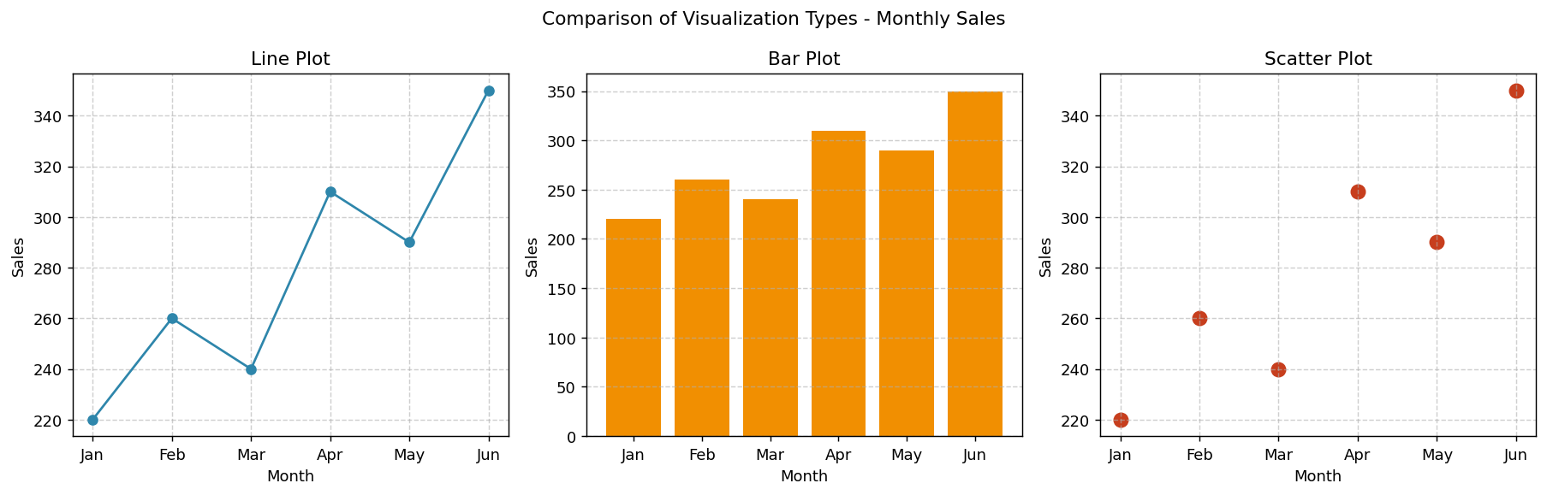

Justification
- Line plot: best for showing the continuous month-to-month trend and overall trajectory of sales.
- Bar plot: best for comparing the exact magnitude of sales between individual months side-by-side.
- Scatter plot: useful for spotting individual data points, but weakest here since it does not show the sequential/trend relationship between months.
Conclusion: The line plot communicates the data most effectively for this dataset because the primary insight (a rising sales trend over time) is a continuous, time-ordered relationship, which line plots represent best.

Activity 4 — Pandas Visualization Activity
Task: Create a DataFrame containing Product, Sales, and Profit. Generate appropriate visualizations directly using Pandas.

Python Code
import pandas as pd

df = pd.DataFrame({
'Product': ['Laptop', 'Mobile', 'Tablet', 'Headset', 'Monitor'],
'Sales': [150, 320, 90, 210, 130],
'Profit': [45, 60, 20, 55, 35],
})

ax = df.plot(x='Product', y=['Sales', 'Profit'], kind='bar',
figsize=(7, 4.5), color=['#2E86AB', '#F18F01'])
ax.set_title('Product-wise Sales and Profit')
ax.set_xlabel('Product'); ax.set_ylabel('Amount')
ax.grid(True, axis='y', linestyle='--', alpha=0.6)
plt.show()

DataFrame
Product | Sales | Profit
Laptop | 150 | 45
Mobile | 320 | 60
Tablet | 90 | 20
Headset | 210 | 55
Monitor | 130 | 35

Output
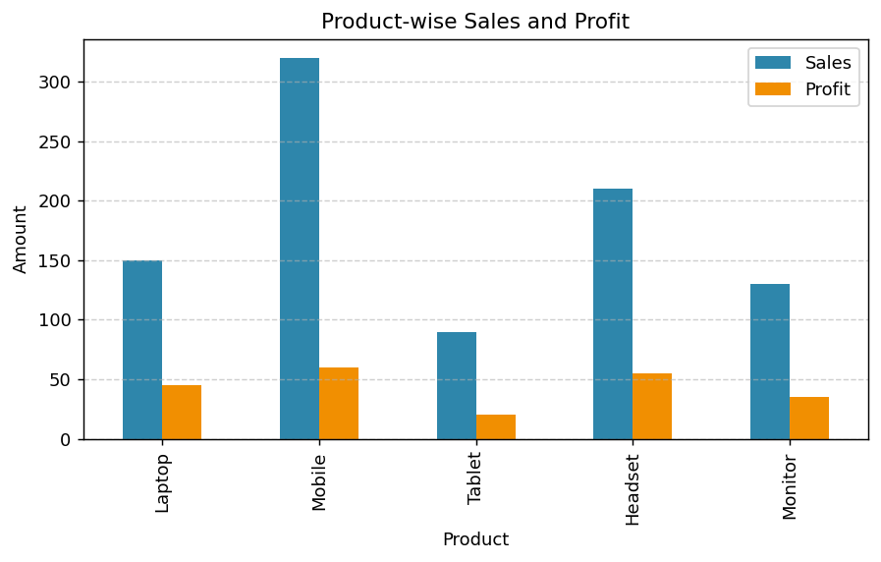
Observation: Mobile has the highest sales and profit, while Tablet has the lowest of both, showing a generally proportional relationship between sales volume and profit.

Activity 5 — Trend Visualization
Task: Use monthly/weekly data to identify increasing, decreasing, and fluctuating trends using a line plot.

Python Code
import numpy as np, matplotlib.pyplot as plt

weeks = [f'W{i}' for i in range(1, 11)]
increasing = [10,14,18,21,26,30,35,39,44,50]
decreasing = [50,46,41,38,33,29,24,20,15,11]
fluctuating = [25,30,22,28,20,33,24,29,21,27]

plt.figure(figsize=(8, 4.5))
plt.plot(weeks, increasing, marker='o', label='Increasing Trend', color='#2E86AB')
plt.plot(weeks, decreasing, marker='s', label='Decreasing Trend', color='#C73E1D')
plt.plot(weeks, fluctuating, marker='^', label='Fluctuating Trend', color='#6A994E')
plt.title('Weekly Trend Visualization')
plt.xlabel('Week'); plt.ylabel('Value')
plt.legend(); plt.grid(True, linestyle='--', alpha=0.6)
plt.show()

Output
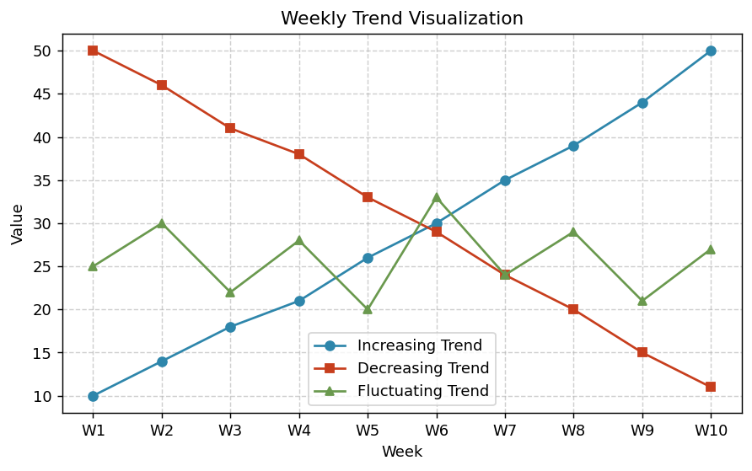

Analysis
- Increasing trend: rises steadily from 10 to 50 across 10 weeks — a consistent upward pattern with no reversals.
- Decreasing trend: falls steadily from 50 to 11 — a consistent downward pattern, the mirror image of the increasing series.
- Fluctuating trend: oscillates between roughly 20 and 33 with no clear long-term direction, indicating volatility rather than a sustained trend.

Activity 6 — Relationship Visualization
Task: Plot two variables such as Advertising vs Sales using a scatter plot. Determine whether the relationship appears positive, negative, or weak.

Python Code
import numpy as np, matplotlib.pyplot as plt

np.random.seed(42)
advertising = np.linspace(5, 50, 25) + np.random.normal(0, 2, 25)
sales = 2.5 * advertising + np.random.normal(0, 8, 25) + 20

plt.figure(figsize=(7, 4.5))
plt.scatter(advertising, sales, color='#2E86AB', edgecolor='black')
plt.title('Advertising Spend vs Sales')
plt.xlabel('Advertising Spend (in $000)')
plt.ylabel('Sales (in units)')
plt.grid(True, linestyle='--', alpha=0.6)
plt.show()

print(np.corrcoef(advertising, sales)[0, 1]) # correlation coefficient

Output
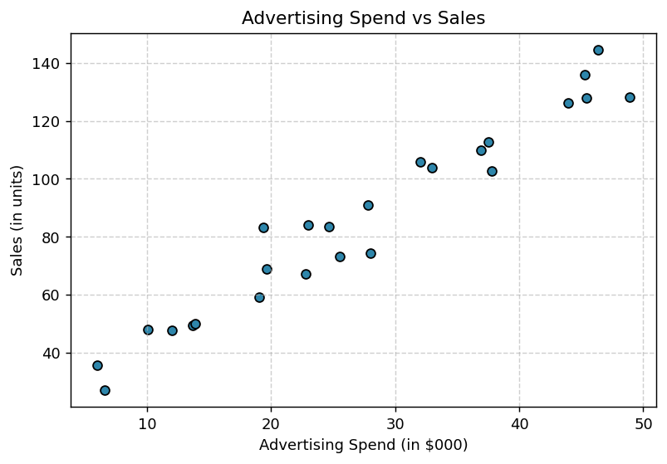
Correlation coefficient ≈ 0.975
Interpretation: The scatter plot shows points rising steadily from lower-left to upper-right with little scatter, and the correlation coefficient (≈0.97) confirms a strong positive relationship — higher advertising spend is associated with higher sales.

Activity 7 — Distribution Visualization
Task: Create a histogram of student marks or employee salaries. Identify the approximate shape, center, spread, and possible skewness.

Python Code
import numpy as np, matplotlib.pyplot as plt, pandas as pd

np.random.seed(7)
marks = np.clip(np.random.normal(68, 12, 200), 0, 100)

plt.figure(figsize=(7, 4.5))
plt.hist(marks, bins=12, color='#F18F01', edgecolor='black', alpha=0.85)
plt.title('Distribution of Student Marks')
plt.xlabel('Marks'); plt.ylabel('Frequency')
plt.grid(True, axis='y', linestyle='--', alpha=0.6)
plt.show()

print(marks.mean(), np.median(marks), marks.std(), pd.Series(marks).skew())

Output
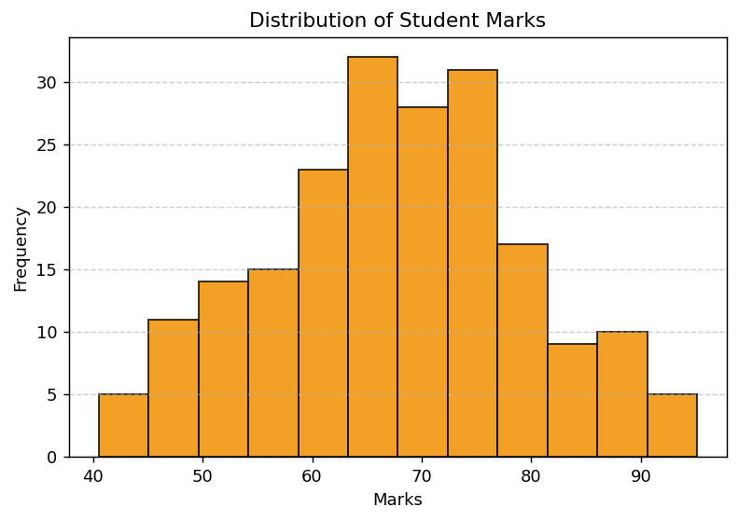

Observations
- Shape: approximately bell-shaped / symmetric, resembling a normal distribution.
- Center: mean ≈ 67.7, median ≈ 67.7 — mean and median are nearly equal, confirming symmetry.
- Spread: standard deviation ≈ 11.9 marks, indicating moderate variability around the center.
- Skewness: skewness coefficient ≈ 0.00, so the distribution is essentially not skewed (neither left- nor right-skewed).

Activity 8 — Frequency Visualization
Task: Create a categorical dataset such as department-wise employee count. Represent the frequencies using a bar chart.

Python Code
import pandas as pd, matplotlib.pyplot as plt

dept_df = pd.DataFrame({
'Department': ['HR', 'IT', 'Finance', 'Marketing', 'Operations'],
'Employees': [18, 45, 25, 30, 38],
})

plt.figure(figsize=(7, 4.5))
plt.bar(dept_df['Department'], dept_df['Employees'],
color='#6A994E', edgecolor='black')
plt.title('Department-wise Employee Count')
plt.xlabel('Department'); plt.ylabel('Number of Employees')
plt.grid(True, axis='y', linestyle='--', alpha=0.6)
plt.show()

Output
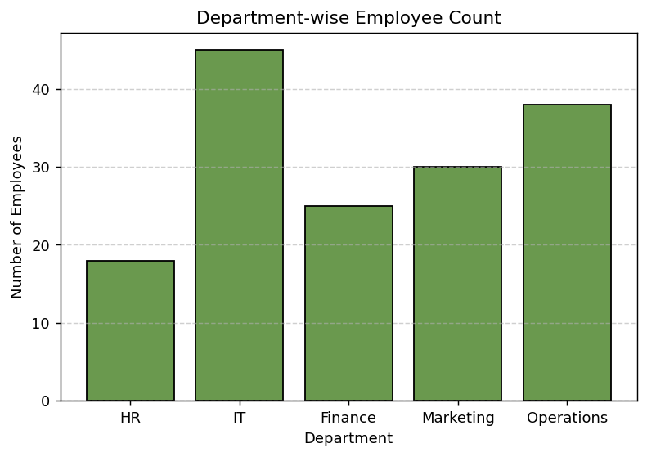
Observation: IT has the largest workforce (45 employees), followed by Operations (38) and Marketing (30), while HR has the smallest headcount (18), reflecting typical staffing patterns in a technology-driven organization.

Activity 9 — Scatter Matrix Visualization
Task: Use a dataset containing at least four numerical variables. Generate a scatter matrix and identify the strongest visible relationships.

Python Code
import numpy as np, pandas as pd
import pandas.plotting as pdplt, matplotlib.pyplot as plt

np.random.seed(1)
n = 100
age = np.random.randint(22, 60, n)
income = age * 800 + np.random.normal(0, 5000, n) + 15000
expenditure = income * 0.4 + np.random.normal(0, 2000, n)
savings = income - expenditure + np.random.normal(0, 1500, n)

df = pd.DataFrame({'Age': age, 'Income': income,
'Expenditure': expenditure, 'Savings': savings})

pdplt.scatter_matrix(df, figsize=(9, 9), diagonal='hist',
color='#2E86AB', alpha=0.6)
plt.show()
print(df.corr().round(3))

Output
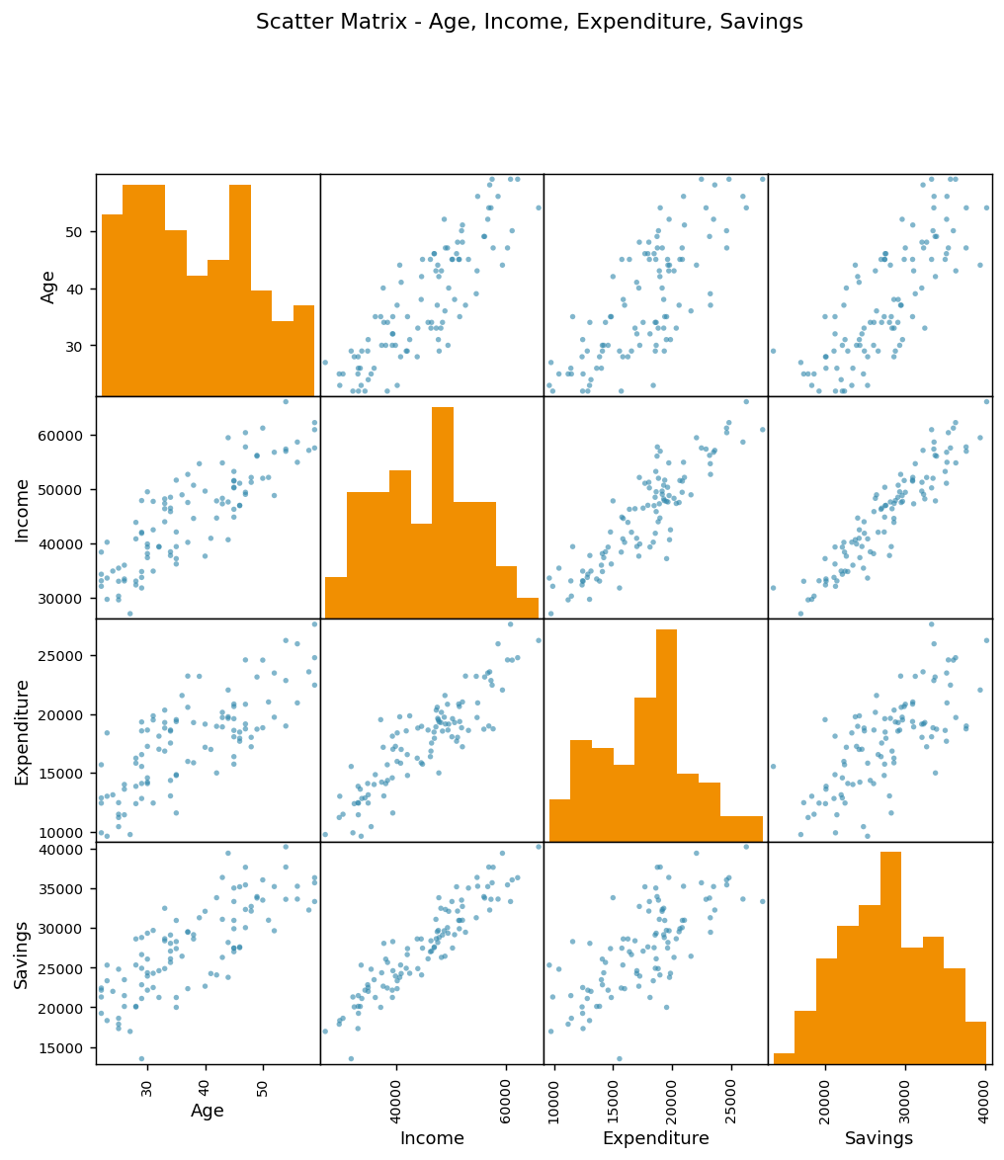

Correlation Matrix
 | Age | Income | Expenditure | Savings
Age | 1.000 | 0.849 | 0.763 | 0.784
Income | 0.849 | 1.000 | 0.890 | 0.932
Expenditure | 0.763 | 0.890 | 1.000 | 0.716
Savings | 0.784 | 0.932 | 0.716 | 1.000

Findings
- Strongest relationship: Income vs Savings (r ≈ 0.93) — a strong positive relationship.
- Income vs Expenditure (r ≈ 0.89) is also strongly positive, as expected since expenditure was modeled as a proportion of income.
- Age vs Income (r ≈ 0.85) shows a strong positive relationship, consistent with income rising with age/experience.
- Expenditure vs Savings (r ≈ 0.72) is the weakest of the strong relationships, showing more spread in the scatter plot.

Activity 10 — Lag Plot Visualization
Task: Use time-series data to create a lag plot. Examine whether the current observation appears related to the previous observation.

Python Code
import numpy as np, pandas as pd
import pandas.plotting as pdplt, matplotlib.pyplot as plt

np.random.seed(3)
t = np.arange(0, 100)
ts = 50 + 10 * np.sin(t / 5) + np.random.normal(0, 2, 100)
ts_series = pd.Series(ts)

plt.figure(figsize=(6, 6))
pdplt.lag_plot(ts_series, lag=1, c='#2E86AB', alpha=0.7)
plt.title('Lag Plot (lag = 1) of Time Series')
plt.grid(True, linestyle='--', alpha=0.6)
plt.show()

Output
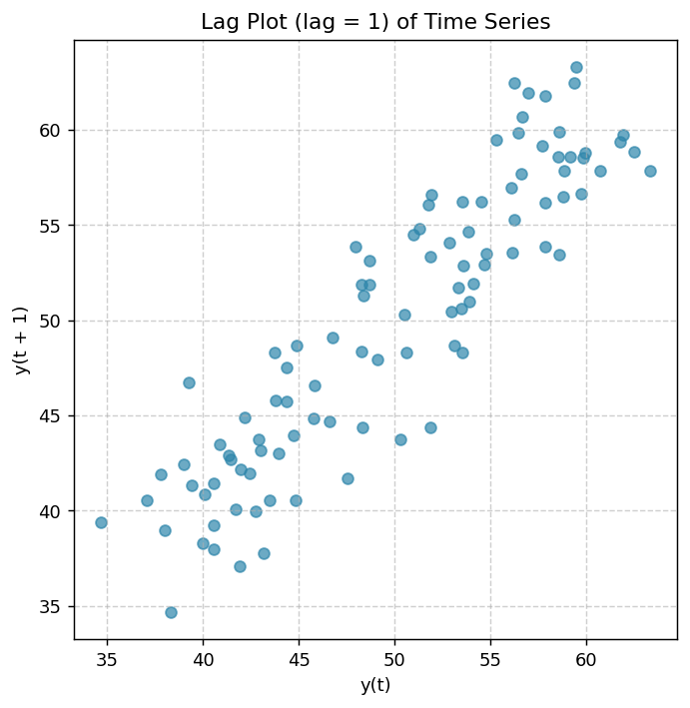
Conclusion: The points form a clear elongated elliptical / curved pattern rather than a random cloud, indicating strong autocorrelation — each observation is closely related to the previous one. This is expected since the underlying series is a smooth sinusoidal signal with only small random noise.

Activity 11 — Autocorrelation Visualization
Task: Generate an autocorrelation plot for a time series. Identify lags with relatively strong positive or negative autocorrelation.

Python Code
import pandas.plotting as pdplt, matplotlib.pyplot as plt

plt.figure(figsize=(7, 4.5))
pdplt.autocorrelation_plot(ts_series)
plt.title('Autocorrelation Plot of Time Series')
plt.show()

Output
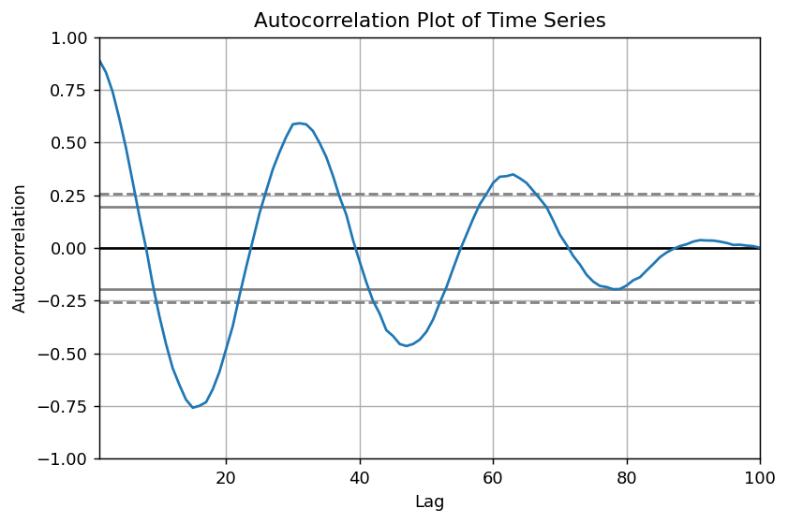

Analysis
- Small lags (roughly 1–8): autocorrelation is strongly positive and close to 1, since the sine wave changes gradually.
- Around lag ≈ 16 (a quarter period of the sine wave): autocorrelation crosses zero and becomes negative.
- Around lag ≈ 31 (half the period): autocorrelation reaches its most negative value, showing the series is roughly out of phase with itself.
- The oscillating pattern of the autocorrelation plot itself confirms the underlying periodic (sinusoidal) structure of the time series.

Activity 12 — Bootstrap Visualization
Task: Select a numerical dataset, repeatedly resample it, and examine the distribution of a chosen statistic such as the mean.

Python Code
import numpy as np, pandas as pd
import pandas.plotting as pdplt, matplotlib.pyplot as plt

np.random.seed(11)
data = pd.Series(np.random.normal(100, 15, 60))

fig = pdplt.bootstrap_plot(data, size=50, samples=500, color='#C73E1D')
plt.show()

print(data.mean(), data.std())

Output
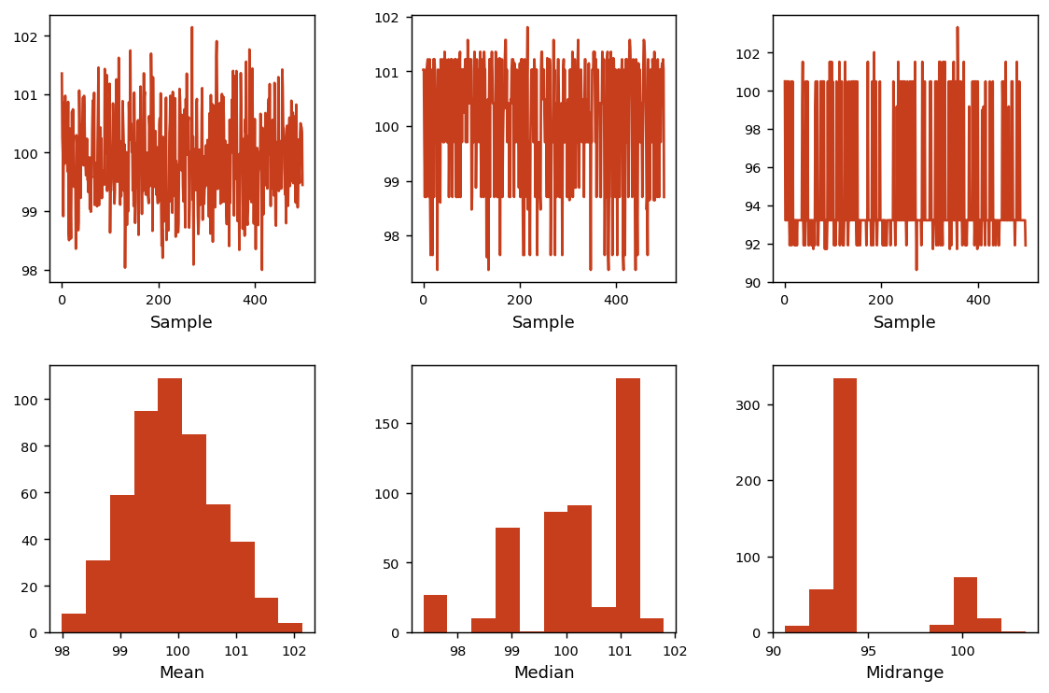

Interpretation
Original sample mean ≈ 99.9, standard deviation ≈ 13.25.
- The top-left/top-right/bottom-left plots show the resampled means, medians, and mid-ranges fluctuating around a stable central value across the 500 bootstrap iterations.
- The histograms (right column) show that the distribution of the bootstrapped mean is approximately bell-shaped and centered close to the original sample mean, illustrating the Central Limit Theorem in action.
- The narrow spread of the bootstrapped mean's histogram compared to the original data indicates that the sample mean is estimated with good precision from this dataset.
— End of Solutions —

